**THE TABLEAU HR SCORECARD: MEASURING SUCCESS IN TALENT MANAGEMENT**

1. INTRODUCTION

**1.1 OVERVIEW**

* + A talent management strategy defines how talent will be used to support the **organization goals.**
  + Talent management functions should not operate independently.
  + Many talent management models exist and most start with planning and **acquisition process.**

**1.2 PURPOSE**

* + - * + The purpose of talent management is to identity, recruit and hold on to people who drive the success of your organization
        + Performance and talent management is a key function of the modern HR department.
        + These people develop the talent the powers their growth and effectiveness.

**2.PROBLEM DEFINITION &DESIGN THINKING**

* Empathy map
* Brainstorming map

**EMPATHY MAP**

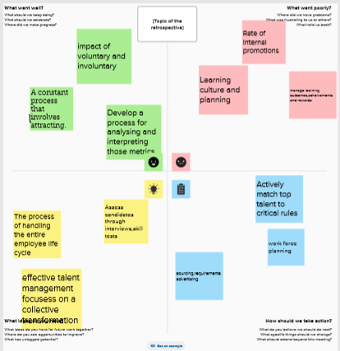

**BRAINSTORMING MAP**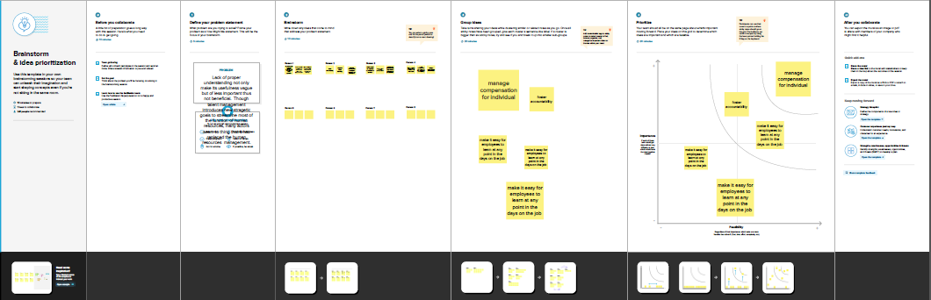

**3.RESULT**

* Collect the dataset
* Dataset connect with tableau

**COLLECT WITH DATASET**

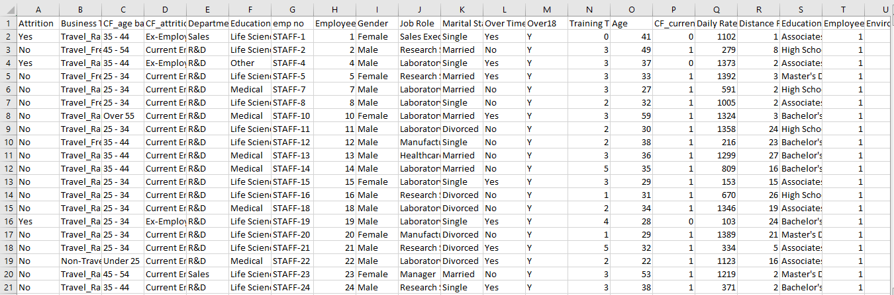

**DATASET CONNECT WITH TABLEAU**

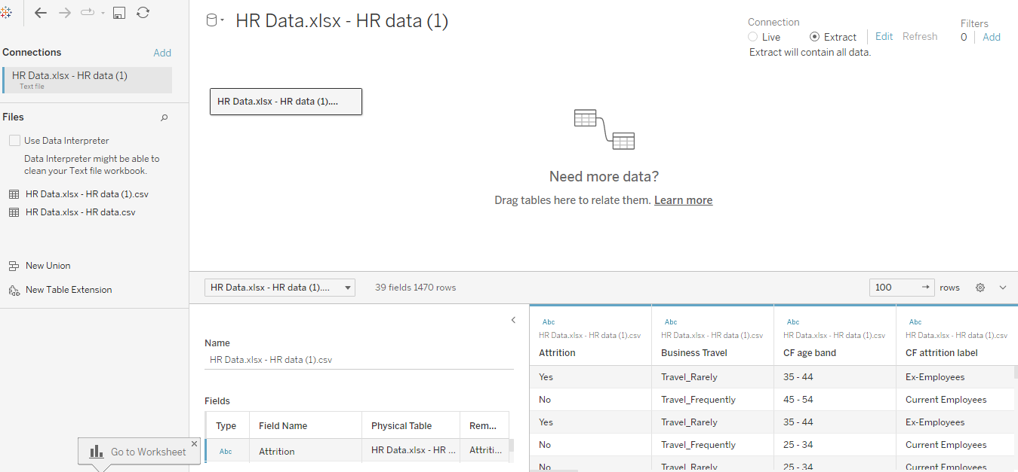

**DATA VISUALIZATION:**

* Department wise attrition
* Job satisfaction rating
* **Average salary**
* **Average salary hike**
* **Average age**
* **Number of employees**

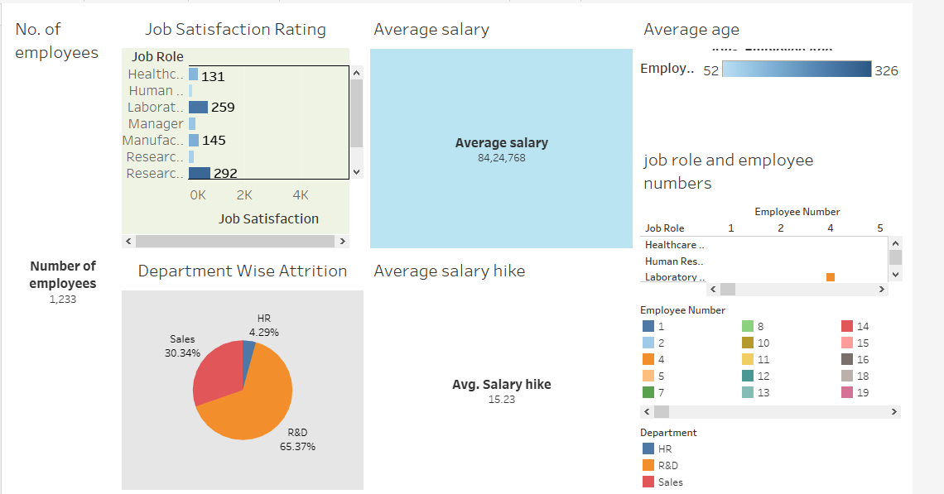**DASHBOARD:**

**STORY:**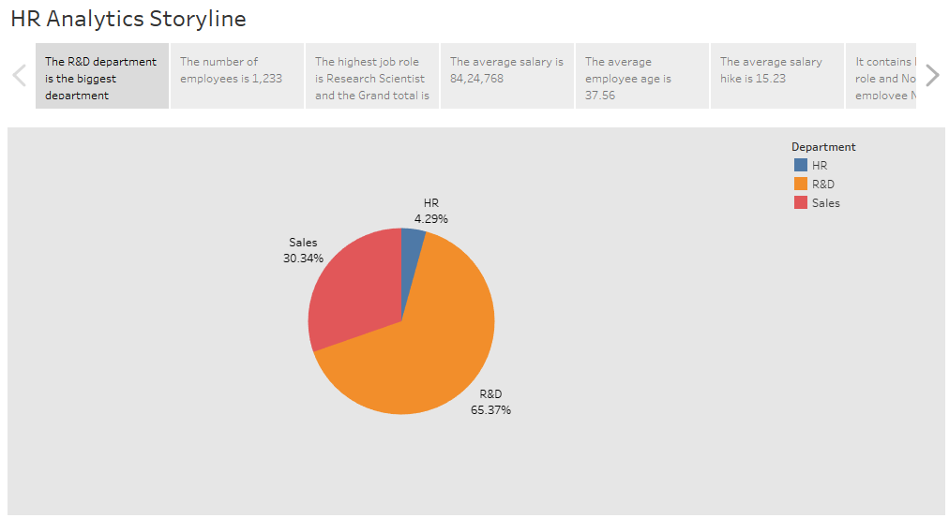

**4.ADVANTAGES AND DISADVANTAGES:**

**ADVANTAGES**

* Help in ascertaining the right person is deployed in the right position.
* Promotes effective communication across different disciplines.
* **Better hiring by hiring assessments.**

**DISADVANTAGES:**

* **The implementation of talent management program could be expensive in terms of time,resources and financial costs.**
* **Lack of support from line managers can impede the level of commitment from employees.**

**5.APPLICATIONS:**

* **A talent management system is an integrated software platform that supports core talent management process, including recruitment ,employee onboarding, performance management,learining and professional development ,succession planning.**

**6.CONCLUSION:**

* **Talent management has become one of the most important buzzwords in corporate HR and training today. Organizations know that they must have the best talent in order to the succeed in the hypercompetitive and increasingly complex global economy. They must manage talent as a critical resource to achieve the best possible result in the long run.**

**7. FUTURE SCOPE:**

* The future of talent management.
* **A responsive and reactive approach to talent management.**
* **Little consideration of how careers are changing.**
* **The event was divided into three breakout sessions to facilitate free-flowing.**

**8.APPENDIX:**

**Source code**

**Dataset**

[**https://smartinternz.s3.amazonaws.com/The_Tableau_HR_Scorecard_Measuri**](https://smartinternz.s3.amazonaws.com/The_Tableau_HR_Scorecard_Measuri)

**ng_Success_in_Talent_Management.pdf**

**Dashboard**

|  |
| --- |
|  |

<https://public.tableau.com/views/dashboard_16964820050640/Dashboard1?:language=en-US&publish=yes&:display_count=n&:origin=viz_share_link>

**STORY**

|  |
| --- |
|  |

https://public.tableau.com/views/story_16964834414650/story?:language=en-US&publish=yes&:display_count=n&:origin=viz_share_link